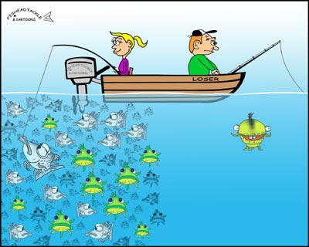
A hook is named for its ability to catch the reader’s attention.
HOOKS
The key is to say something the reader can relate to by incorporating the motif of the book and the essay/thesis.
In Lit Response, the topic will be in the hook, summary, and thesis.
Hooks should not be in the form of a question.

Types of Hooks:
- Startling Statement – All human beings are capable of the most gruesome crimes imaginable. It is only because of the customs and controls of civilization that humans do not become brute savages.
- Shocking Statistic –A recent, anonymous survey discovered that over ninety percent of high school males admit to secretly enjoying the music of ‘N Sync (“I Made This Up”).
- Analogy – The models that grace the pages of magazines seem to be better than anyone confronted in actual reality. Just as magazine covers are manipulated to hide imperfections, the public often deceives itself into ignoring the flaws of people whom have been built up into perfect beings.
- Questions Turned to Statements
  - Many people contemplate the meaning of life but arrive at different conclusions.
  - Each person takes his or her experiences and incorporates them into daily life in practical and professional ways.
  - Hollywood has an intriguing past.
  - Famous people have the money to be able to reside anywhere in the world, yet many reside in one location.

Now you try. Here is your thesis: Taylor warns her readers that dehumanizing others ultimately affects the one who is dehumanizing through the characters of Kaleb Wallace, Cassie Logan, and Mr. Jamison.

Now you try. Here is your thesis: The Community leaders withhold books, memories, and emotions in order to remain all-powerful.

